Student Enrollment — Parent & Student Onboarding Automation

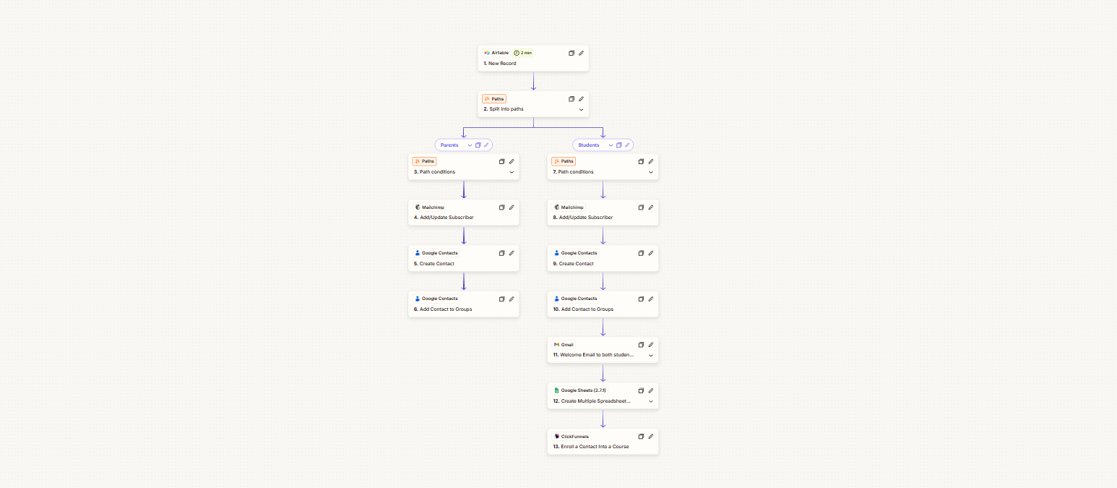

Project Description
A multi-step enrollment automation built to manage new records coming into Airtable and automatically determine whether the contact is a parent or a student. From there, each contact follows the appropriate path, with the workflow handling contact synchronization, communication, onboarding, and course enrollment without requiring manual setup at every stage.
The student path takes the process further by preparing the student across the required platforms, sending a welcome message, setting up the necessary spreadsheet, and enrolling them into the appropriate course.

Automation Scope
- Airtable new-record trigger
- Parent and student identification
- Conditional workflow routing
- Separate parent and student processing
- Mailchimp subscriber creation and updates
- Google Contacts creation
- Contact group assignment
- Automated student welcome email
- Google Sheets setup
- ClickFunnels course enrollment
- Cross-platform contact synchronization
- Automated student onboarding

Workflow
Airtable New Record → Split Into Paths
Parent Path → Path Conditions → Mailchimp Add/Update Subscriber → Google Contacts Create Contact → Add Contact to Groups
Student Path → Path Conditions → Mailchimp Add/Update Subscriber → Google Contacts Create Contact → Add Contact to Groups → Welcome Email → Google Sheets Create Spreadsheet → ClickFunnels Enroll Contact Into Course
The workflow begins with a new Airtable record and uses conditional routing to determine whether the contact is a parent or student. Parents are added and organized across Mailchimp and Google Contacts, while students continue through the additional onboarding steps, including welcome communication, spreadsheet setup, and ClickFunnels enrollment.

Key Objective
Automate the enrollment and onboarding journey from the initial Airtable entry through contact management and course enrollment, while keeping parent and student records on their appropriate paths and ensuring each new student is properly prepared across the connected platforms.

